Grant Project Unit (200 pts)
In this unit, you will imagine you and your group are applying for a grant to solve a need of your community (whether that be the campus community, or a community elsewhere in NYC). You will be completing (most of) the typical steps of a preparing a grant proposal.
Since this is a group project, the grading is slightly different. You will receive a group grade on the project as a whole, which will serve as a base grade for your individual score. Your group members will be evaluating the effort you put into this project and I will keep those evaluations in mind when assigning individual grades at the end of this unit. You will be creating a Gannt chart and writing a group contract for this project. If you do not hold up your end of the contract (ie, you do not communicate, you miss group meetings, you skip class when I give group time to work, you do not do the work you agreed to do, etc.), I will ask you to complete this entire project individually.
Grant Project Checklist:
____ Abstract 20 pts
____ Problem Statement 15 pts
____ Project Narrative (with sources cited) 100 pts
____ Budget 15 pts
____ Timeline (GANNT Chart) 20 pts
____ Presentation 30 pts

Problem Statement:
Due 04/16
75-150 Words
Before any grantor will give you money, you must identify a need or a problem that your project will be solving. In 75-150 words, you will describe the opportunity, challenges, issues/need within the community that your proposal addresses.
This unit will be much easier if, as a group, you identify a real problem or need within a community to address, such as an increased homeless population or lack of access to fresh and healthy foods. In the problem statement, you should also be sure to define who is affected by the problem you notice.
Example Problem Statement: Over a year ago, a condominium developer dug a pit at Lot 48 on Sullivan street in Pawnee, Indiana to build a basement but went bankrupt in the middle of the construction project. The site remains abandoned in an otherwise residential neighborhood. Not only is the unsightly dirt pit an eyesore for the community, it also poses a safety risk. Walking home late at night, a neighborhood man fell into the pit, breaking both of his legs. As Sullivan Street is also the home to several families with children, this safety hazard is especially concerning.

Timeline/Gannt Chart:
Due 04/16
A Gantt chart, commonly used in project management, is one of the most popular and useful ways of showing activities (tasks or events) displayed against time. On the left of the chart is a list of the activities and along the top is a suitable time scale. Each activity is represented by a bar; the position and length of the bar reflects the start date, duration and end date of the activity. This allows you to see at a glance:
- What the various activities are and who will be working on them
- When each activity begins and ends
- How long each activity is scheduled to last
- Where activities overlap with other activities, and by how much
- The start and end date of the whole project
While a grant proposal typically asks for a Gannt Chart of the project itself, I am asking you to create a Gannt chart for the completions of the activities you must complete in this unit (problem statement, abstract, budget, drafts of project narrative, presentation preparation steps, etc.). LOOK AT THE CLASS SCHEDULE FOR DUE DATES AND STEPS IN THIS PROJECT. There are some smaller steps that I have asked you to complete that you should include on this Gannt Chart.
Your Gannt Chart is how you will make sure that your group members are participating equally and how you will evaluate your group members when the project is completed.
You can find a template online, or create your own.
Example Gannt chart (yours will be more extensive):
Task Name | 04/13 | 04/14 | 04/15 | 04/16 | 04/17 | 04/18
Write problem statement
Create Gannt Chart
Find Prospective Grant
Find one Source

Red= Ann Perkins
Blue= Leslie Knope
Green= Andy Dwyer

Budget:
Due 04/23
Your budget will break down the expenses of your grant for the grantors. You may either create a spreadsheet of your own for this, or fill out the example I have provided on the Readings and Resources page. If your proposed project requires a lot of materials, you may want to use the example as a guide, while creating your own spreadsheet. Your first step is brainstorming a list of all materials your project will require to complete. Next, you will look up the prices of those materials and catalogue them in your budget report.
In the budget, while the cost does not have to be spot on, I do not want you arbitrarily making up prices. There is no writing in this portion of the project, so I expect you to do a little research once you have come up with your list of expenses. Should your staff be making minimum wage, or are their positions typically paid more? How much do standard office supplies cost? How much does postage cost to mail surveys to 200 participants?

Project Narrative:
Draft 1: 04/23
Final Draft: 05/02
4-6 Pages
The project narrative will contain the bulk of your grant proposal. It is here that you will describe the nature of your project, how it will address the community need/problem that you identified in your problem statement. The key to a good project narrative is to be as specific as possible-this is where you anticipate an answer any questions the grantors might have about your project.
Your project narrative should first give a background of your problem and the people it affects, incorporating the research you have done. Perhaps this background research provides statistics regarding your problem; perhaps outlines what other communities have done to address similar problems; perhaps it includes an analysis of the community (cultural, historical, demographical, etc.); perhaps it does a combination of these.
Next, your project narrative should describe the nature of your proposed project. You will describe the exact activities for which you are requesting funding.
- Describe your overall goal(s) regarding the problem you noticed; what are the objectives or ways in which you will meet those goal(s)?
- Describe how this focus was determined and who was involved in that decision-making process.
- How will the proposed activities benefit the community, being as clear as you can about the impact you expect to have?
- Who will carry out the activities in the proposed project?
- What is the timeframe in which this will take place?
Finally, your project narrative will describe how you plan to measure the outcomes of your project. Funding is often based on measurability, so this part is quite important. Describe your criteria for the project's success, how you will measure the changes, and use the evaluation results?
- Will you survey participants?
- Is your effectiveness numbers based (like tracking the amount a video has been shared)?
- Will you give your participants action cards (cards containing desirable outcome actions that they can chose from, ie after viewing an educational video on healthcare, participants pick between cards saying “will talk to my family about healthcare options,” “will never talk about healthcare,” “will write my local representatives about healthcare options,” or “will donate to healthcare initiatives”).
- Will you interview select participants?
- Will you do a combination of these measurements, or something entirely different?
Whatever your method for measuring outcomes, you must be specific. If you plan to survey participants, include a sample of your survey questions. If you are tracking numbers, what number equals success; how do these numbers translate into real world change? Why is that methodology effective for you project?
Abstract:
Due: Your Presentation Date (05/07 or 05/09)
250-500 Words
The abstract gives your readers their first glance at your project. It should be succinct and written in the future tense and should condense what you have written in the project narrative. You will outline:
- The problem you are addressing.
- What your project is.
- How your project goals address the identified problem.
- How you will measure those goals.
Your abstract should be written AFTER your project narrative is completed (or mostly completed).

Presentation:
Due: Your Presentation Date (05/07 or 05/09)
10 Minutes
You will be presenting your project to the class with some kind of visual aid (PowerPoint, Prezi, etc). The content of this project will be the bulk of your project narrative; however, you should not just stand in front of the class and read your project narrative word for word. Rather, you will take the most engaging and important parts and relay them to the class.
Whereas the rest of your project is narrative in nature, in the presentation you can appeal to your audience using images. Images can be key in relating the importance of your project, so use your visual aid wisely. For example, if Ann Perkins really wanted to show the dangers of the pit to a board of grantors, she could include this picture of the pit: 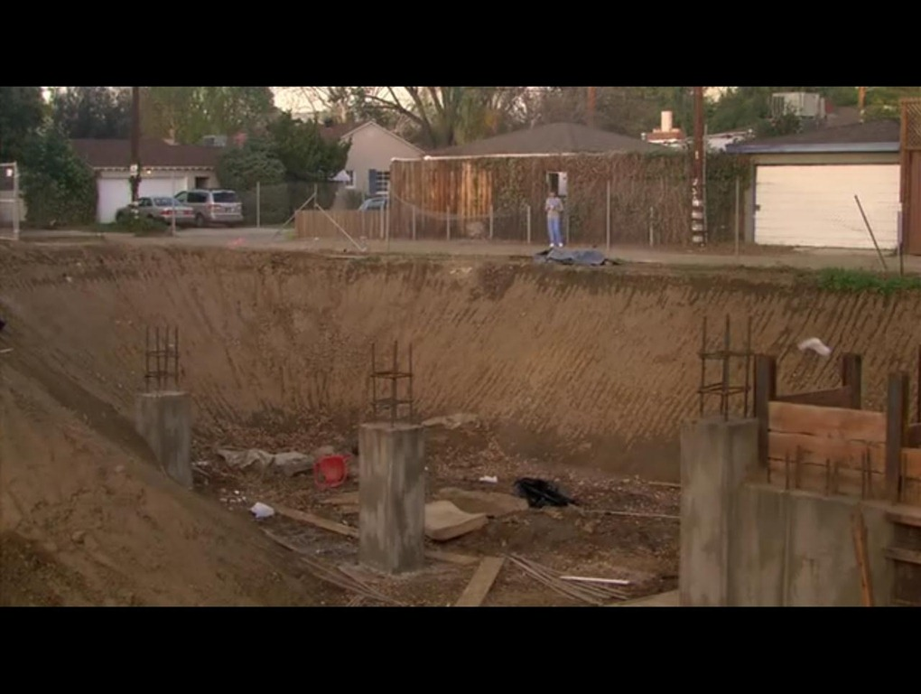
And explain how the steep edges depicted in the picture can be especially dangerous, or how the construction materials in the bottom of the pit could cause extra injuries for someone who falls in.

